I have pre-hashed the passwords of attorneys to “password”

Login using one of the following:

A)

Username: [sumit@yopmail.com](mailto:sumit@yopmail.com)

Password: password

B)

Username: meeru@yopmail.com

Password: password

C)

Username: ishaan@yopmail.com

Password: password

To simplify the logic, the attorneys that are available will be considered for send-email. An attorney can be made available by passing the attorney-id to the end point: **/attorneys/{attorney_id}/available**

## Working Code in VSCode:

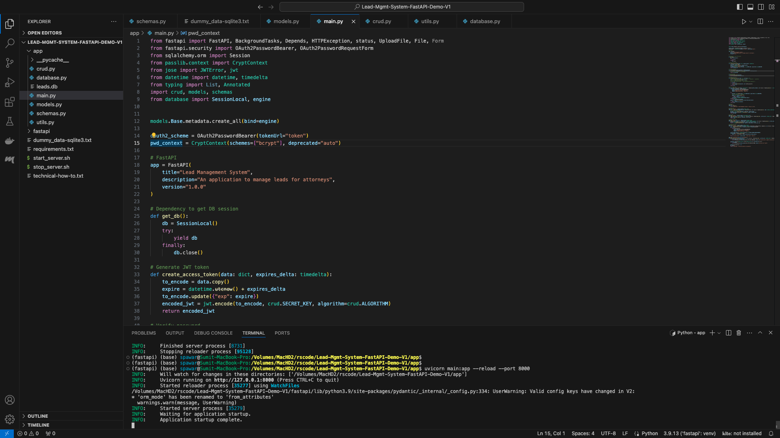

## Default JSON Output

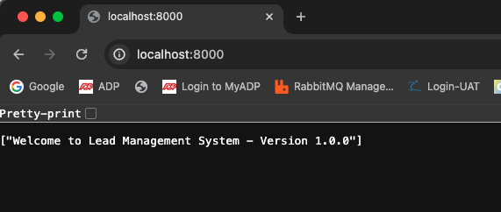

## Swagger UI Docs:

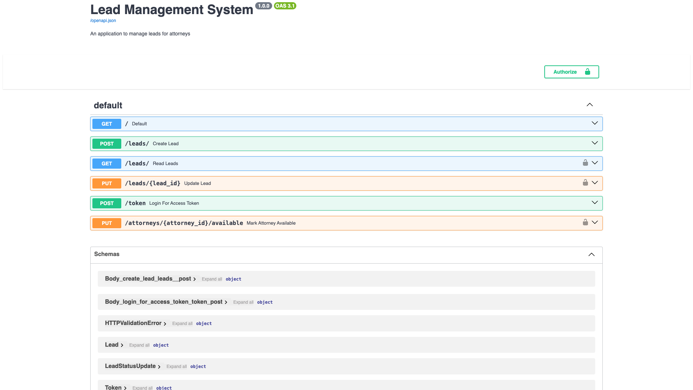

## Swagger UI - JSON Output for default home “/” path

## Swagger UI Authentication passed for sumit@yopmail.com

## Swagger UI - Add Leads Request

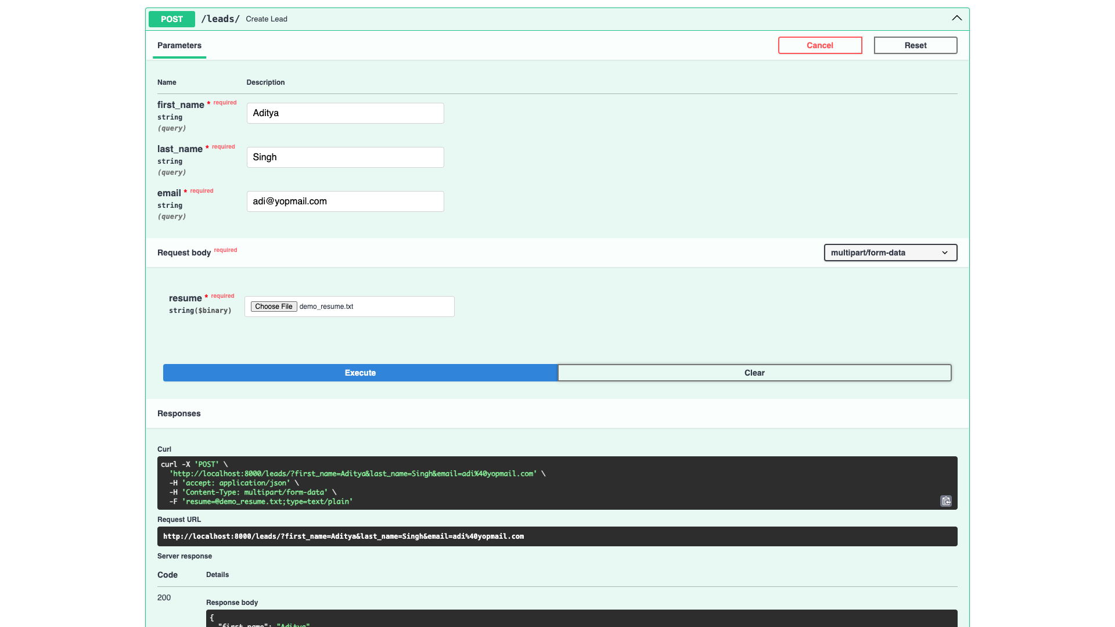

## Swagger UI - Add Leads JSON Response

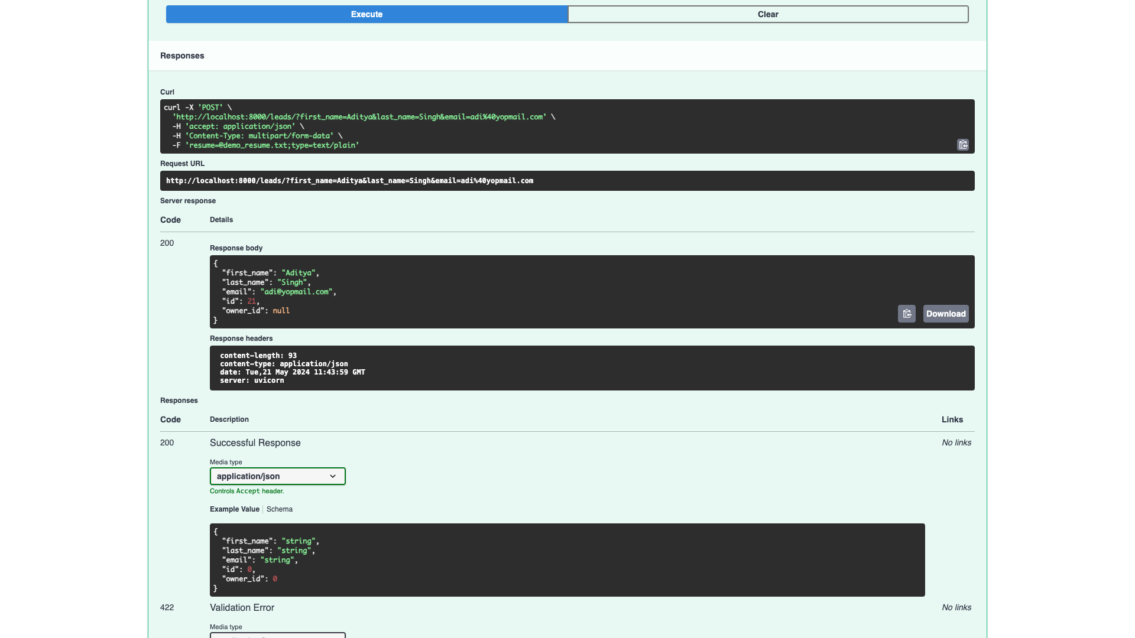

## Display Leads - requires auth

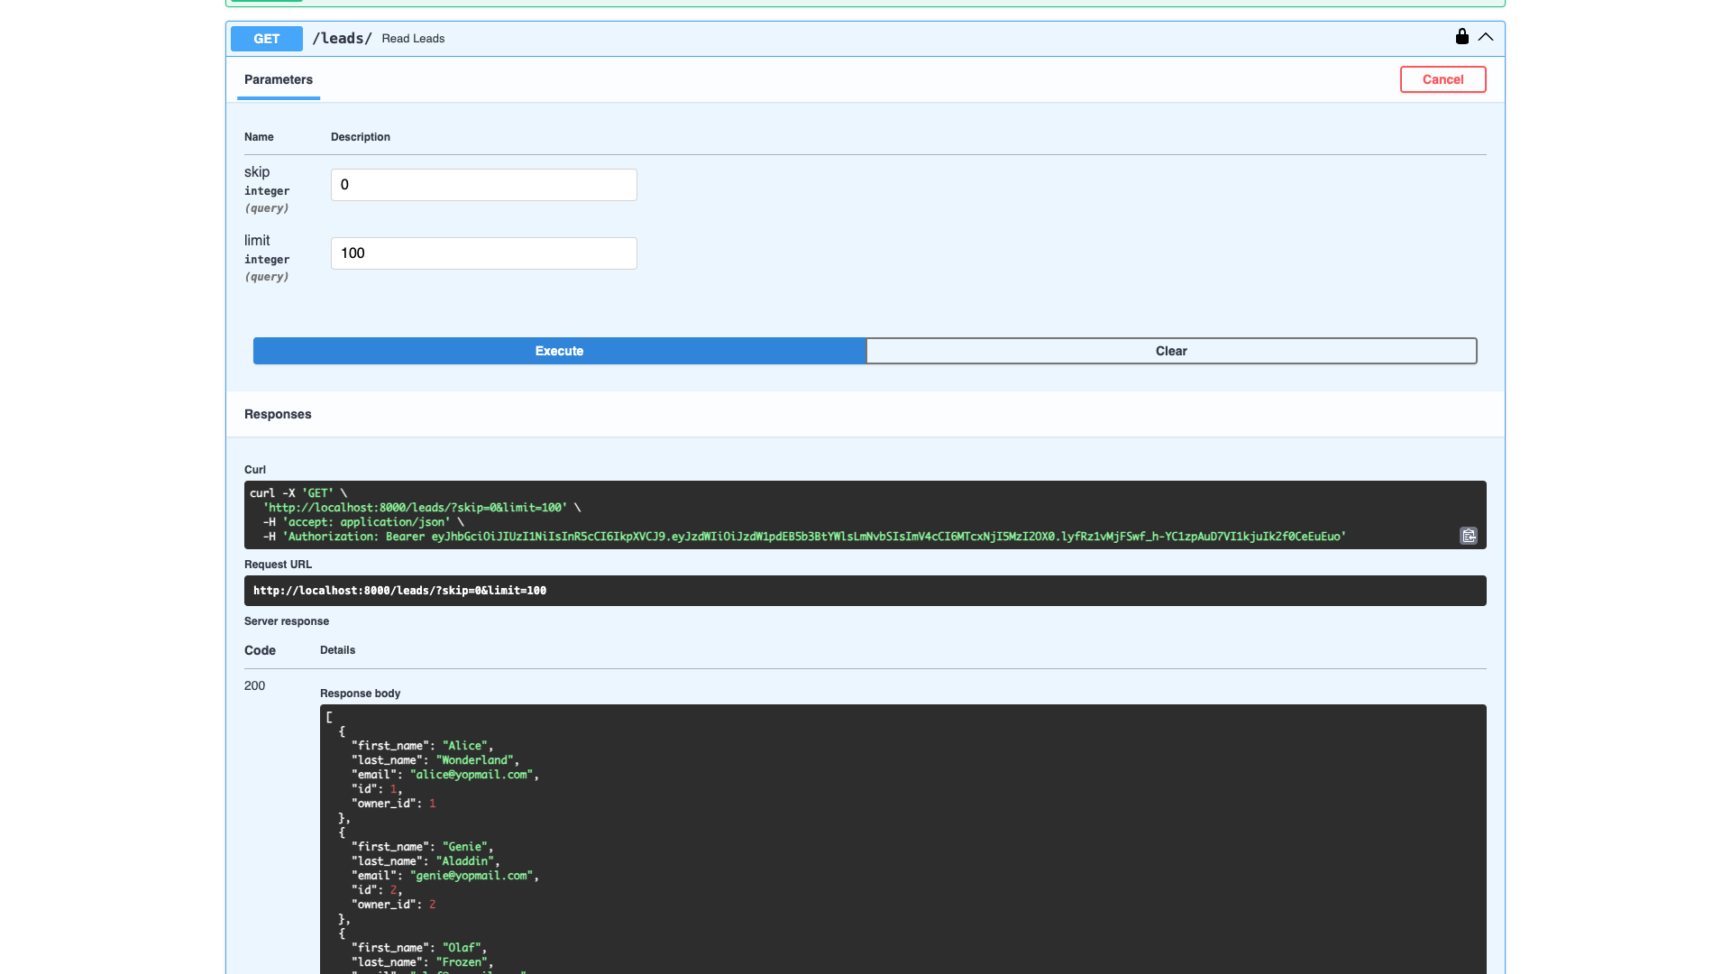

## Display Leads Response

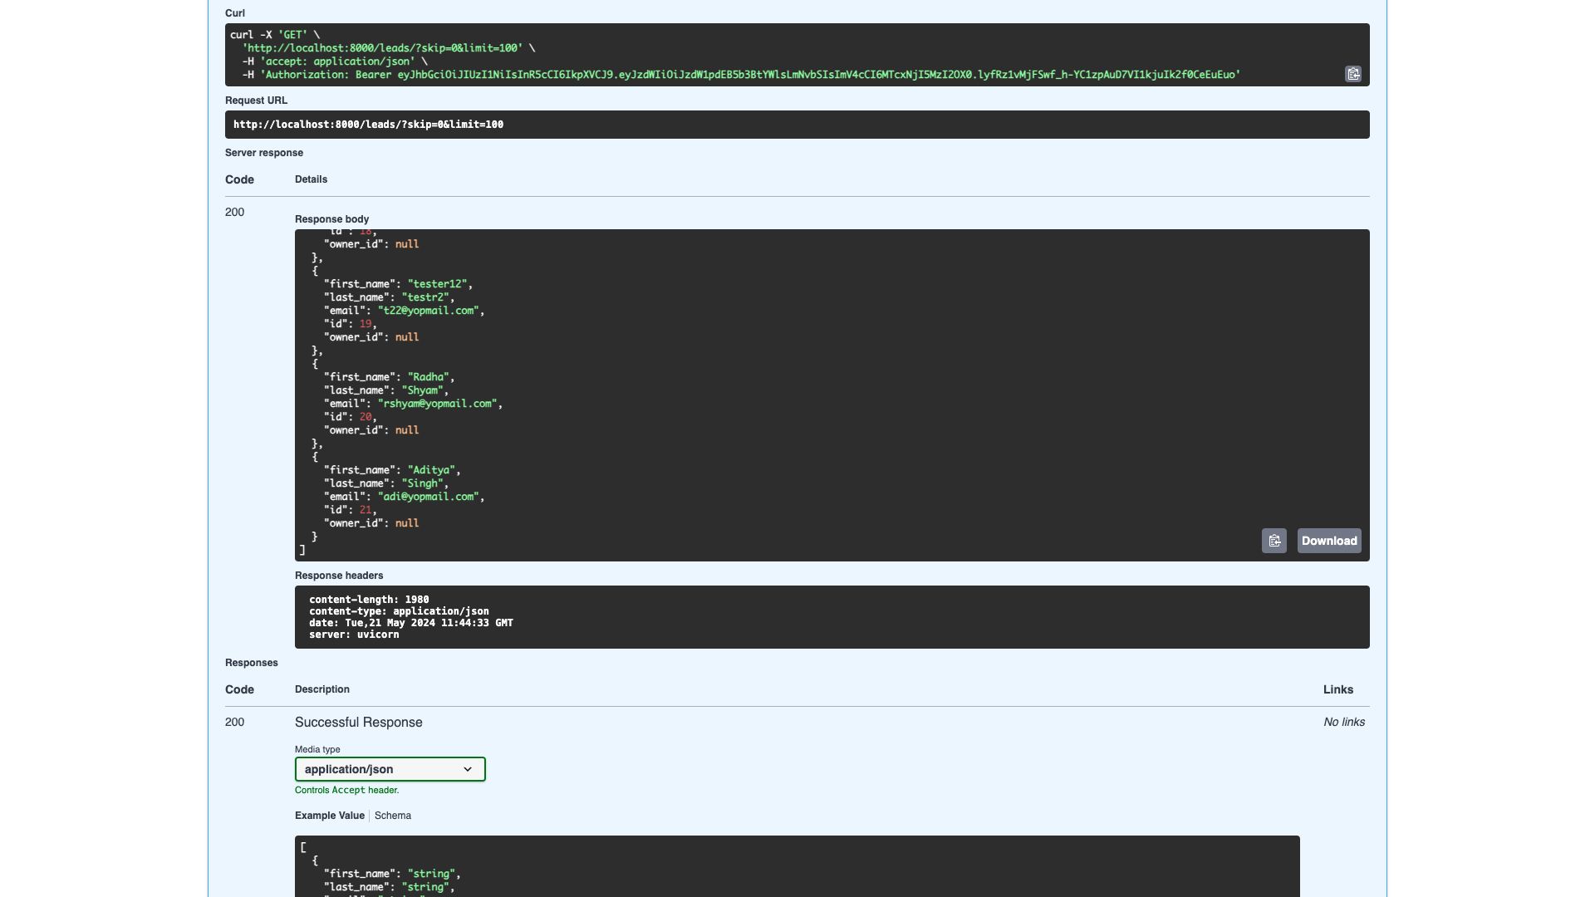

## Remaining APIs

## APIs & Schemas

